Early-Stage Solution Architecture
Problem Chosen: Smart Road Damage Reporting & Rapid Response System for Solapur Municipal Corporation
List of subsystems
S.No | Subsystem Name | Functionality
1. | Sensing Subsystem | Detect road damage using Ultrasonic Sensor & MPU6050
2. | Image Capture Subsystem | Capture road damage images using Camera Module
3. | Location Tracking Subsystem | Provide real-time GPS coordinates
4. | Processing Subsystem | Raspberry Pi processes data & calculates severity
5. | Communication Subsystem | GSM/Wi-Fi sends data to cloud
6. | Cloud & Storage Subsystem | Store road damage data securely
7. | Dashboard Subsystem | Display damage location & severity to authorities
8. | Escalation & Alert Subsystem | departments & Forward issue to relevant Commissioner if delayed

Solution architecture is a high level structural design that defines how different subsystems and components of a system interact to solve a specific problem .
It describes the arrangement of hardware, software,data , communication and user interfaces required to deliver the intended functionality.
The proposed IoT-based Road Damage Detection and Severity Mapping System is broken down into several subsystems to ensure a modular design and effective interaction among the various components. Each subsystem has a particular function that interacts with other subsystems in terms of energy, information, material, or space.

Subsystems Interaction matrix

Internal System:
- Sensors
- Processing
- Communication
- Power regulation
- Mechanical enclosure

External Systems:

Vehicle battery
- Internet infrastructure
- Cloud hosting service
- Municipal monitoring office
- Road surface (environment)

From / To | Ultrasonic | Accelerometer | Camera | GPS | Cloud | Processing | Dashboard | Mechanical
Ultrasonic | - | - | - | - |  | Distance data (pothole depth in cm) | - | Spatial: Mounted facing road
Accelerometer | - | - | - | - | - | Info: Vibration data (XYZ acceleration m/s²) | - | Spatial: Fixed to chassis
Camera | - | - | - | - | - | Info: Road image frames (JPEG/video) | - | Spatial: Forward/downward orientation
GPS | - | - | - | - | - | Info: Latitude, Longitude, Timestamp | - | Requires sky visibility
Cloud | - | - | - | - | - | - | Info: Dashboard data (maps, severity alerts) | Virtual subsystem
Processing | Control signals | Control/config | Camera trigger | Data parsing |  | - | - | Mounted inside housing
Dashboard | - | - | - | - | User queries, issue assignment | - | - | Used in municipal office
Mechanical | Sensor alignment | Vibration coupling | Camera angle fixing | GPS mounting | - | Enclosure & cooling | - | _

Architecture Diagram
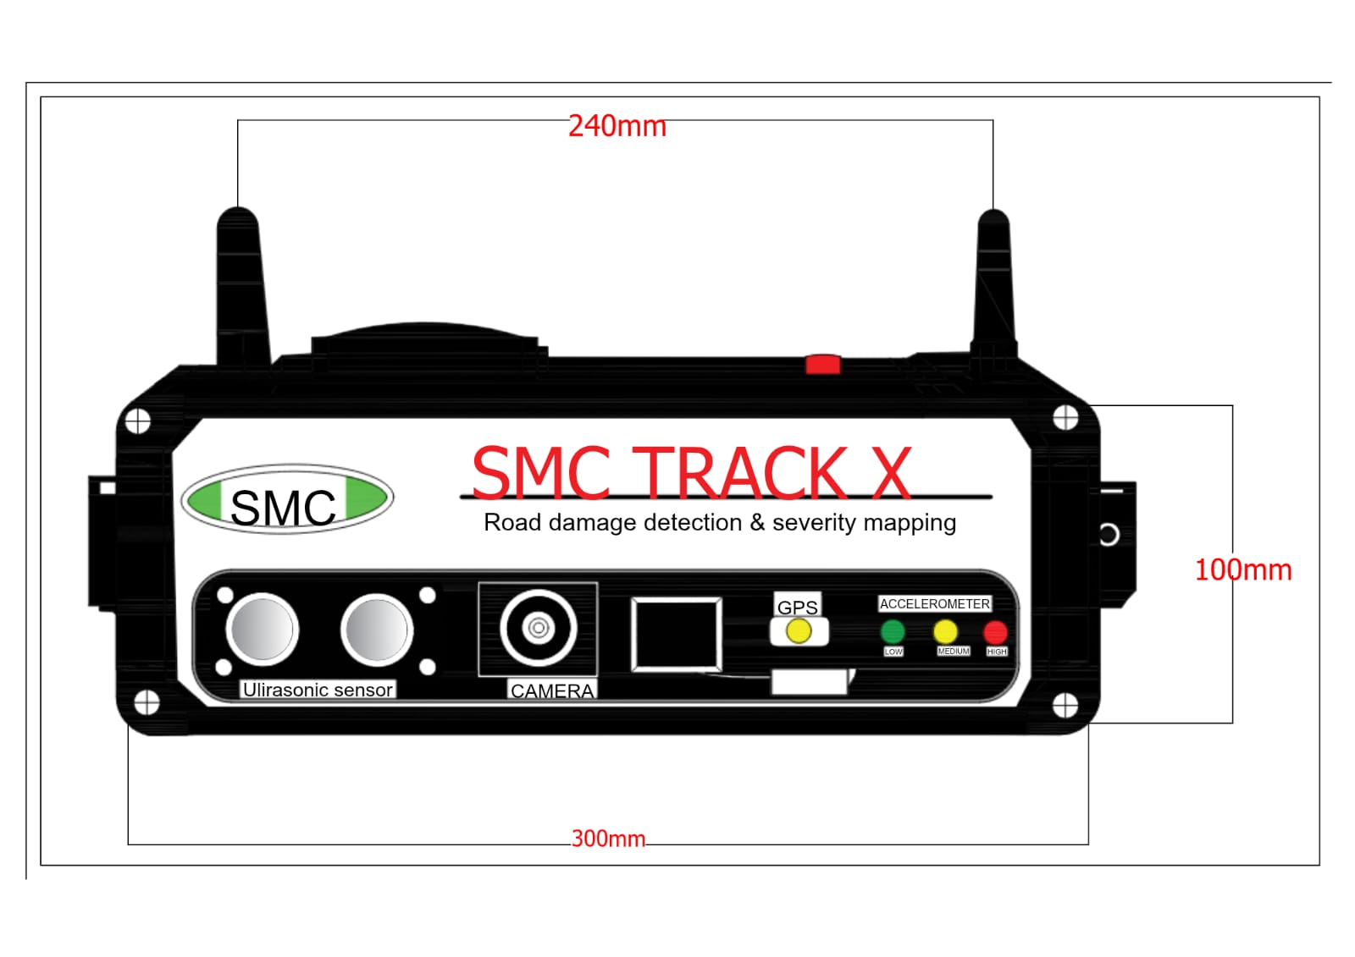
SMC Track X is an IoT edge-to-cloud solution that aims to identify road damage in real-time through sensors mounted on vehicles. It is a multi-layered system that combines sensing, processing, communication, cloud analysis, and dash-boarding.
Architectural Characteristics
- Modular design.
- Scalable (multiple vehicles supported).
- Real-time detection.
- Fault-tolerant communication.
- Cloud-based analytics.
- Clear subsystem boundaries
- Easy maintenance & upgrade

